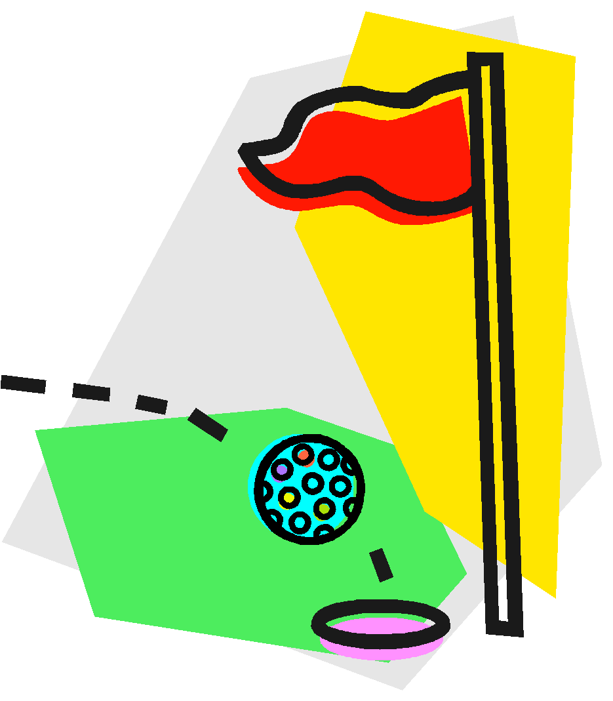 GOLF STUDY GUIDE
ABOUT GOLF:
Golf is a game in which all individuals can play regardless of size, strength, age or gender. Golf as we play it today on a golf course with 9 or 18 holes had its origin in St. Andrew’s, Scotland. The game of golf was introduced to the United States around 1880 by Robert Reid.

OBJECT OF GOLF:
The object of golf is to MOVE from the teeing area to the green and into the hole in the fewest number of strokes. The total number of strokes taken on a hole is recorded as a score. At the end of 9 or 18 holes, the scores on each hole are added for a total score for the golf course.

GOLF HOLES:
Each hole has a designated par which is the established stroke standard for the given length of the hole in yards. The designated pars are 3 (shorter length holes), 4 (medium length holes) and 5 (longer length holes).

PARTS OF A GOLF HOLE
Tee Area: the designated area for beginning each hole.
Fairway: the short grass between the tee area and the green.
Rough: the long grass parallel to the fairway.
Green: the putting surface (closely mowed grass).
Hazard: sand traps and water on the course.
Out-of-Bounds: area that is not part of the golf course.

SCORING
Par: standard score set for a hole.
Birdie: one stroke less than par.
Eagle: two strokes less than par.
Bogie: one stroke more than par.
Double Bogie: two strokes more than par.
Triple Bogie: three strokes more than par.

ETIQUETTE AND SAFETY
A. “Honors” -player with the lowest score on the previous hole hits first on the next tee.
B. On the fairway, the player whose ball is farthest from the green hits first.
C. When a player is hitting, other players should stand quietly. They should stand to one side of the player hitting, not in front.
D. The warning cry “fore” should be yelled if a ball is in the air and other players are in danger of being hit.
E. A player should be sure no one is in front of or behind them when swinging a club or hitting a ball.
F. Players should always replace divots and repair ball marks on the green.

Play It As It Lies
What that means is pretty simple - don't move or touch the ball!

Water Hazards
Water hazards take a 1-stroke penalty and drop a ball at any point behind the spot where your original ball crossed into the water hazard.

CLUB SELECTION
A. The higher the trajectory (height and angle of ball) needed, the more lofted club should be used (higher number clubs).
B. The greater the distances needed the less lofted clubs are selected (smaller numbered clubs).

