 **Tennis Study Guide** 

**History**

The modern game of lawn tennis was created in 1873 in **England** for use at **lawn parties**. It rapidly became popular in other countries, including the United States. As the popularity grew, many tournaments were established. The most important match in the United States is the U.S. Open held annually in New York and can be **seen on T.V.**

**Important Facts**

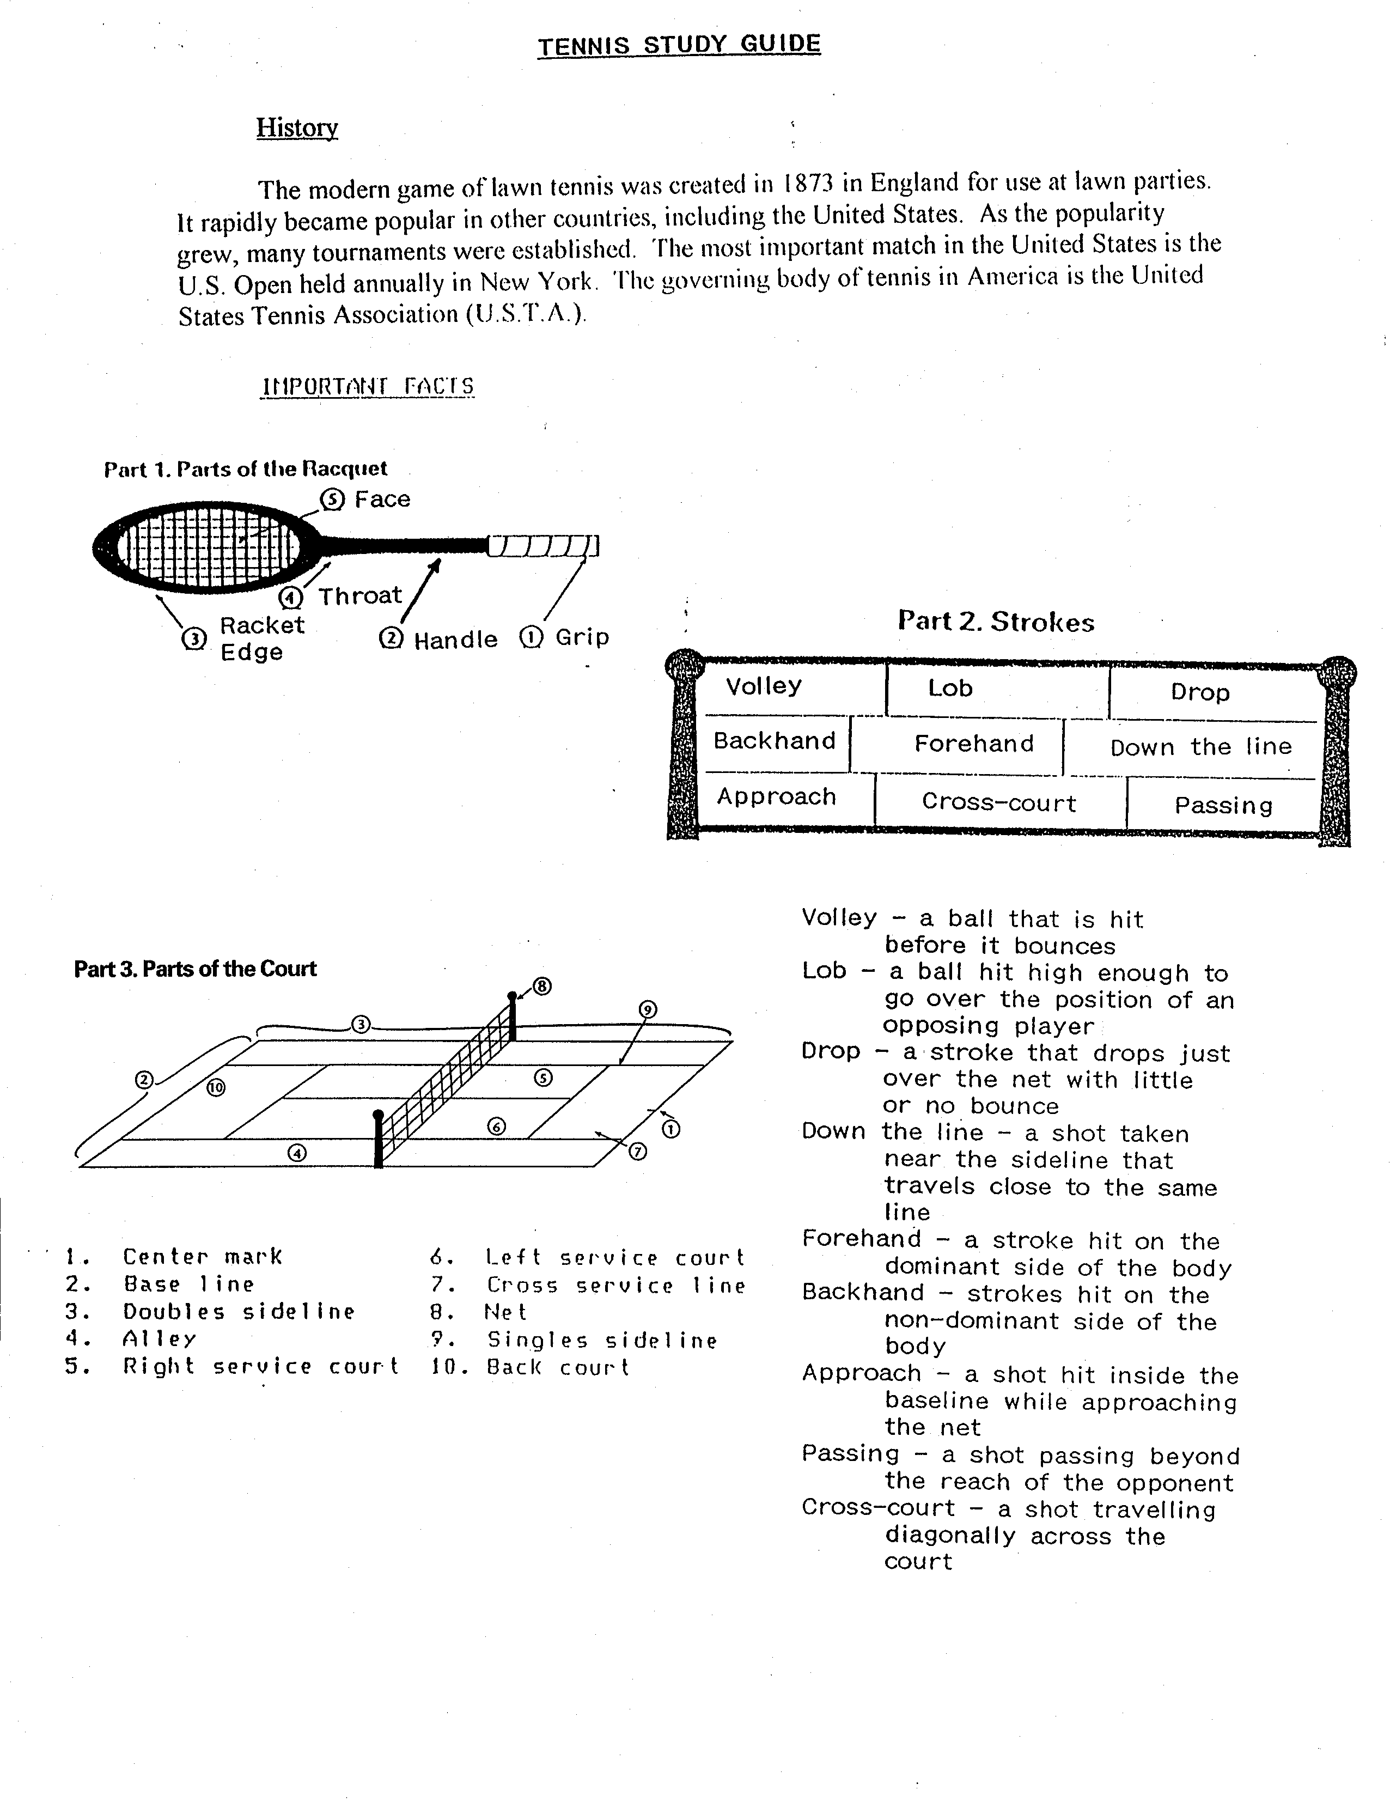 **Parts of the racket/ court**:

**Type of hits**:

**Volley** – a ball that is hit before it **bounces**

Lob – a ball hit high enough to go over the position of an opposing player

Drop – a hit that drops just over the net with little or no bounce.

Down the line – a shot taken near the sideline that travels close to the same line

**Forehand** – a hit on the **racket hand side** (dominant side) of the body.

Backhand – hit on the non-dominant side of the body.

Approach – a shot hit inside the baseline while approaching the net

Passing – a shot passing beyond the reach of the opponent.

Cross-court – a shot traveling diagonally across the court.

**Strategies**:

1. aim for **corners**
2. short / deep shots
3. hard / soft shots
4. high / low shots
5. spin on the ball

*** and many more

*** After a shot go center and be in **READY POSITION**!!!

**Basic Rules and Scoring for Tennis**

One player serves one entire game and the points are ordered as **Love, 15, 30, 40, Game.** The server serves from **behind the baseline and to the right of the center mark**. The server gets **two** chances to get the serve in the proper box. After each point is made, the server rotates from the right to the left of the center mark. Any tennis ball landing on any line is considered **IN**.

* Deuce – if a score in a game becomes tied at 40 – 40 it is called deuce and one player **must win by two points**. If the server wins the point, it is called “advantage in” (ad in). If the receiver wins the point it is called “advantage out” (ad out).
* Court changes – the players change sides of the court at the end of the first, third, fifth… games of each set.
* Sets and matches – seven games make up a set. Most matches, and all women’s matches are made up of three sets.
* Tie-breaker – in a set, one player must win by two games. If the score of games won in a set become tied at 6-6, a tie-breaker is played. The tie-breaker consists of winning five out of nine points.