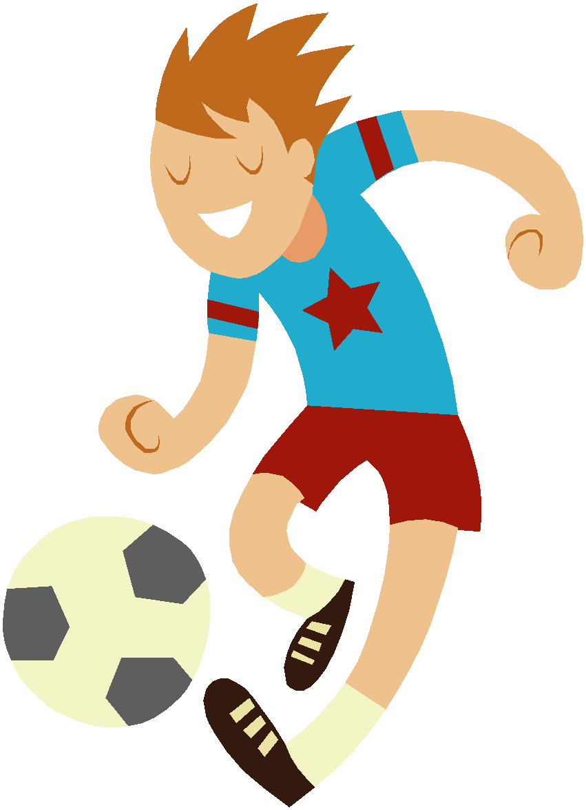 Soccer Study Guide

Soccer is the most widely played team game and most popular spectator sport in the world. Soccer was originally called Futbol. Soccer is different from American and Canadian Football in that it is primarily played with the feet. Only goalies may handle the ball in their designated area. Soccer is considered to be a faster game than American Football because players must improvise their tactics as play proceeds, constantly shifting their positions to receive or intercept passes.

The game of soccer began in England in the mid-19th century. The “World Cup” games are held every 4 years. The World Cup was played in the United States for the first time in 1994. The first women’s World Cup match was played in 1971 in Mexico City. The United States started to catch the soccer fever in the 1970’s, when the Brazilian star soccer player named PELE arrived on the scene.

RULES, REGULATIONS, TERMS:
- The game is played by 2 teams, 11 players on the field each.
- The object of the game is to force the ball past the goalie – by kicking or propelling it without the use of arms or hands.
- One point is awarded for each goal. The winning team is the team with the most goals.
- The game is played in two – 45 minute halves.
- Goal Kick- results when the offensive team kicks the ball over the opposing team’s goal line or end line.
- Corner kick- results when the defensive team kicks the ball over their own goal line or end line.
- Throw-in - when either team kicks the ball over the sideline, the opposing team will be awarded a throw-in.

Square Pass – keywords:
- Non-kicking foot toe points to target
- Use the instep (just below and in front of the ankle) to strike the ball.
- Follow-through to target
- Hit the top half of the ball to keep the ball on the ground

Trapping the ball – keywords:
- Move to the ball
- Position body in front of the ball, trap the ball with the foot, thigh or chest.
- Absorb the force

Support – keywords:
- Move quickly away from the defender
- Move into an open passing lane
- Call for the ball (square right, square, left…)

Throw- In – keywords:
- Use two hands – ball starts behind the head
- Keep both feet on the ground
- Throw directly to the feet of the receiver (teammate)

The Red team (Mary), kicked the ball out of bounds on the sideline, so the Black team (Bill) was awarded a throw-in. The Black team (Bill) performed a legal throw-in to the feet of Ann who trapped the ball. Sam was moving into an open passing lane in front of the goal and called for the ball. Ann heard Sam and looked up to see him running into the open passing lane. Ann used a good square pass to the feet of Sam, who trapped the ball. Sam realized he was wide open, so he took a shot on goal scoring the winning point for his team.

CAUSE AND EFFECT
Red Team kicked ball out-of-bounds.

Black team awarded a throw-in.

SO

Bill made a legal throw-in to the feet of Ann.

Ann traps the ball.

SO

SO

Sam moves into open space~ calling the ball.

Ann square passes the ball to Sam.

Ann used a good square pass to Sam.

Sam scores winning goal.

SO

